Title of the Communication (Times 14pt, bold, centred)
…blank line…
List of authors (ex: R. Fausto and Andrea Gómez-Zavaglia) (times 12 pt, centred)

Addresses [ex: Department of Chemistry, University of Coimbra, 3004-535 Coimbra (Portugal)] (times 10 pt, italic, centred)
corresponding_author@email (times 10pt, centred)
…blank line…
Abstract text (full justified without paragraph indentation; single spacing). Font: times 12 pt.
Please do not change “page set up” parameters of this document and keep margins as they are. Look carefully to the examples provided here and please use the same style of presentation.
Figures and Tables shall be centred in the page and numbered accordingly with their order of appearance in the text. Please avoid use of color in the figures, since they will appear black and white (grey scale) in the final print out. Tables must be concise and prepared using font arial 10 pt.
The abstract (including figures, tables and references) must not exceed one page.
…blank line above figures…
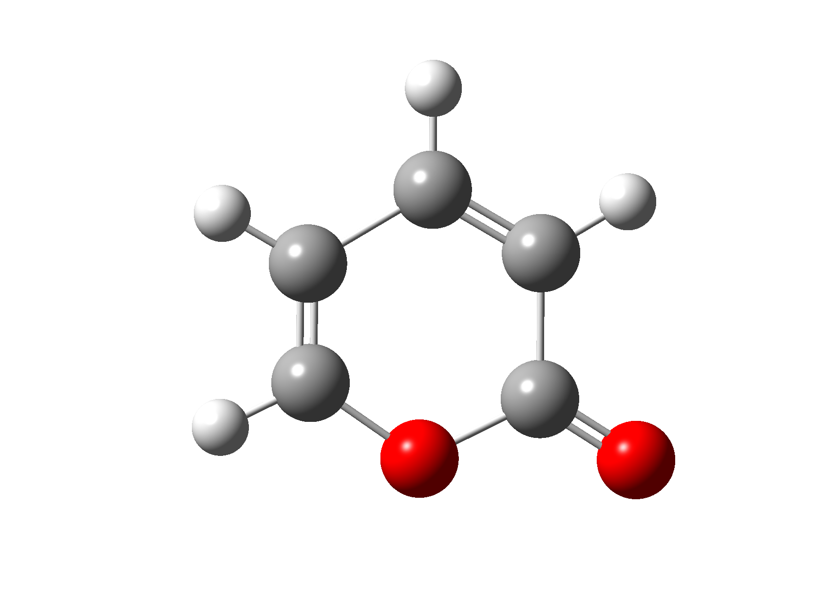
Figura 1 – Legend of the figure (times 10 pt, centred)
…blank line below figures…
References shall be numbered and appear at the end of abstract headed by the word “References”, as illustrated below.

Good work!…
…blank line…

References
…blank line…
1. R. Fausto, C. Cacela, A. Baudot, Cryobiology, 1 (1990) 123.
2. Authors, Journal, Vol. (Year) 1st page.

NOTE: Abstracts should fite above the dashed line (in a 16x18 cm box). Below this line authors should provide the following information:

- Source of funding for the work described
- Any conflicts of interest
- Your preference for oral or poster presentation. Please note that the scientific committee reserves the right to decide upon the mode of presentation.
- The postal and email address of the presenting author
- Your agreement to publication of the Abstract in CRYOBIOLOGY
- Whether the presentation is to be considered for any awards

